INSTALLATION & MAINTENANCE MANUAL

FOR

DOCK LEVELER

CLIENT: - MUKUND CONSTRUCTION.
PROJECT: - BWF TEC INDIA PVT. LTD.

MFG.YEAR: - APRIL 2017

DESIGNED, DEVELOPED & MARKETED

BY



G-BLOCK, 1ST FLOOR, THERMAX CHOWK
MIDC, ABOVE RENAULT SHOWROOM
CHINCHWAD, PUNE-411019

TEL.NO. - +912066304033
EMAIL: -info@nihva.com
www.nihva.com

MANUAL
DOCK LEVELER

A DISPATCH & UNLOADING

1. Loading, for dispatch, will be our responsibility. On receipt of the Dock-leveler at site, please check and ensure that there is no physical damage to the equipment.

2. While unloading the equipment from the transporting vehicle, please ensure to use slings with rated capacity higher than the gross weight of the Stationary lift in packed condition.

3. Slings MUST be hooked ONLY at specified positions. These positions are indicated and marked with a figure of ‘HOOK'. Improper sling position or improper slinging could cause damage to the equipment.

B. ORDERING OF SPARES

1. When ordering for spare, please specify the following in your Purchase Order.

- Equipment Name
- Model Number
- Equipment Serial No.
- Part name / Description
- Part Number
- Quantity required
- Delivery period / time
- Mode of dispatch

This would avoid ambiguity and help us serve you better.

MANUAL
DOCK LEVELER
DATASHEET FOR DOCK LEVELER

CLIENT:
- Construction details

1.1 Required Capacity - each : 6 ton
1.2 Model No. : NDL848
  - Leveler operation mode : AC power pack hydraulically operated
  - Lip operation mode : hydraulic
  - Operation control : by push buttons and control panel
  - Loading platform height from road
Level : 1250 mm (Will be confirmed
During Detailing)
1.7 Travel above & below dock level : (+) 300 / (-) 250 mm
1.8 Platform Size (L x W) : 4000 x 2100 mm
1.9 Lip size (L x W) : 4000 x 400 mm
1.10 Working length : 4400 mm
1.11 Overall length : 4000 mm
1.12 Maximum slope can be achieved : 8 to 10%
1.13 Clear Pit dimensions (W x Lx D) : 2150x 4100 x 485 mm
1.14 Hydraulic power pack
1.14.1 Make “ASK”
1.14.2 Driver type : Direct by electric Motor
1.14.3 Absorbed power : 0.75 kW
1.14.4 Motor Ratings : 0.75/1 kW /HP
1.14.5 Degree of protection for motor: IP 55
1.14.6 Class of Insulation for motor : Class F with temp. Rise limited to
Class B
1.14.7 Motor RPM : 1410
1.14.8 Pump design flow : 2.5 LPM
1.14.9 Pump pressure : 120 bar
1.14.10 Safety valve set pressure : 200 bar or Kg/cm²
1.14.11 in built safety valve : Yes
1.14.12 Pump type : Gear
1.14.13 Valves required : By vendor
1.14.14 Volume of oil receiver : 07 Lit
1.14.15 Dimensions of power pack
Unit : 350 H x 600 L x 325 W mm
1.14.16 First fill of oil / Qty : By Vendor
1.14.17 Hydraulic tubing : By Vendor
1.14.18 Instrumentation : By vendor
1.14.19 Control panel : By vendor
1.15 Overall dimensions (l x w x h) : 2100 x 4000 X 480 mm
1.16 Empty weight : 1500 Kg

DOCK LEVELER
MANUAL

DOCK LEVELLER

INTRODUCTION: -

The hydraulic Dock Leveler is the result of many years' experience in materials handling engineering. “NIHVA” offers the best possible factor of safety with simple, easy to use controls. The high quality of manufacture gives a robust construction and many years of useful life. Each lip and platform movement can be individually controlled (or corrected) by push button.

The dock leveler can be set at any position. During loading, the Dock Leveler is in floating mode i.e. it follows the up/down movements of the vehicle deck. Even with lopsided vehicles, the Dock leveler lip will remain in contact, and toe-traps are avoided by the tilt built into the Dock Leveler.

The whole platform is designed to flex laterally adequately to adapt to sideways tilted vehicles. The leveler always seals perfectly to the lorry bed.

PRINCIPLE: -

Dock Leveler is an adjustable platform used between the transport vehicle and dispatch area of the warehouse of factory for efficient and safe material transfer applications. It bridges the gap between the dispatch area and the transport vehicle and compensates for variations in the truck bed height.
MANUAL

CONSTRUCTION: -

It basically consists of heavy duty fabricated Top Chequered platform and bottom angle channel construction frame. Both are joined by stainless steel machined pins. Lip is hinged to the top platform by means of stainless steel pins.

Top Platform is reinforced with I Beam welded below the platform to strengthen the platform. The cylinder is mounted at the best advantage point against the top platform and bottom frame. Compact power pack includes a single HP motor with overload protection. Hydraulic Pump is Dowty make. Hydraulic operations are by using solenoid control valve.

FEATURES: -

- Convenient location of all controls.
- Independent deck and lip.
- Controls for quicker cycling time.
- Smooth dependable hydraulics.
- Quite operation at the touch of the button.
- Years of trouble-free service.
- Lower lift time cost and fewer maintenance requirements.
- Recommended for all applications.
- Maintenance Strut.
- Hazard Stripes.
- Toe guards.

MANUAL
DOCK LEVELER

PRE – OPERATING INSTRUCTIONS: -

- Ensure Hydraulic Oil in the power pack.
- Ensure Motor connection and proper earthing.
- Ensure joint leakage.
- Ensure proper location of platform and lip.

MANUAL
DOCK LEVELER

ROUTINE MAINTENANCE AND LUBRICATION

These recommendations are applicable to the Dock Leveler considering average daily usage of 15 to 20 times. If it is used more frequently, the same time intervals for the maintenance should be adjusted accordingly.

DAILY: -

- Check Hydraulic pipe lines for leak proof working.
- Check electrical connections for their proper working.

MONTHLY: -

- Grease the hinge pins at bottom frame and top plate joint and extension lip plate hinge joint.

- Grease the main Jack Cylinder and Lip Jack Cylinder, Front and Rear Trunion bearings.

- Change Hydraulic Oil.

DOCK LEVELER
MANUAL

ASSEMBLIES
&
SPARE PARTS LIST

MANUAL
DOCK LEVELER
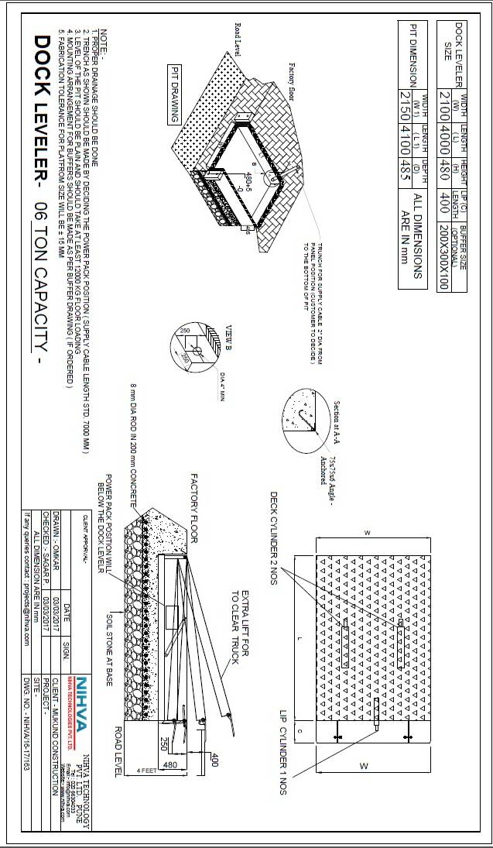

MANUAL
DOCK LEVELER
MANUALDOCK LEVELER
DOCK LEVELER
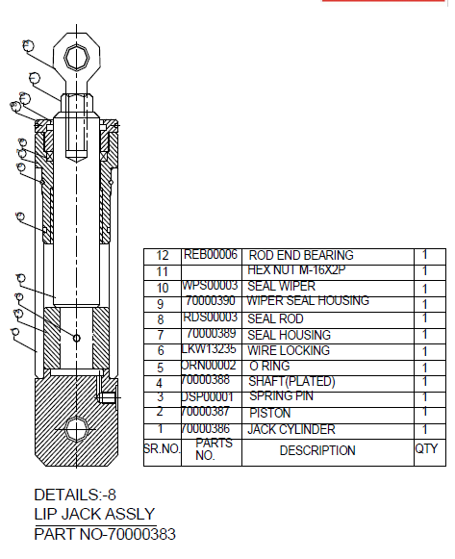

MANUAL
DOCK LEVELER
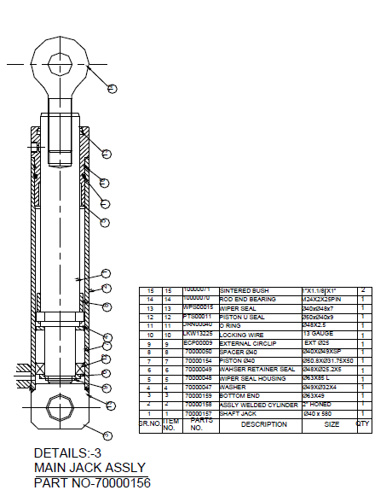
DOCK LEVELER
MANUAL

Mechanical Critical Bought-out Parts

S NO | ITEM DESCRIPTION | QTY. | UNITS
1 | HYD-Ø63-Ø-400 | 2
2 | HYD-Ø50-Ø36-350 | 1

Mechanical Wear Parts

Sr. No. | Units / Part code | Units / Part Description | Qty.
1 | 170006010103 | PIN-1 | 3
2 | 170006010201 | PIN | 2
3 | 170006010301 | PIN-1 | 2

MANUAL
DOCK LEVELER
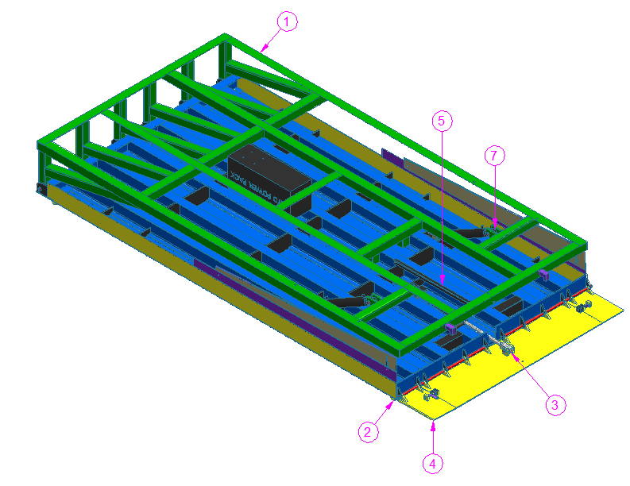

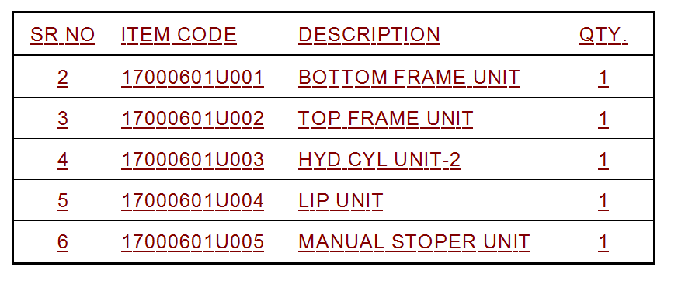

MANUAL
DOCK LEVELER
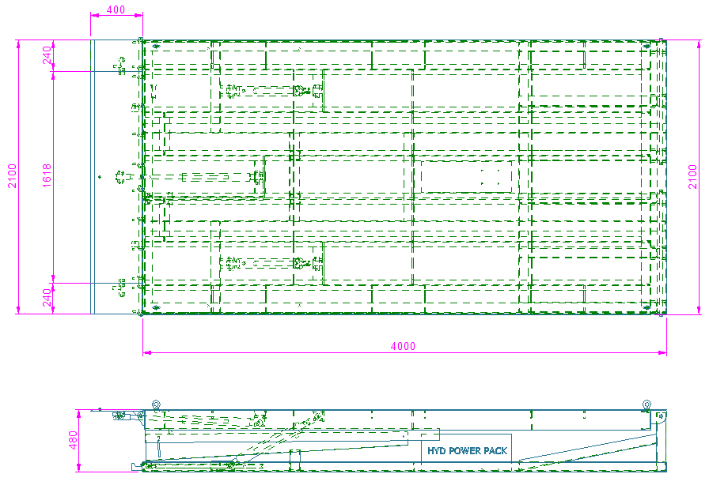

Over all Dimensions views.

MANUAL
DOCK LEVELER

Bottom Frame Unit

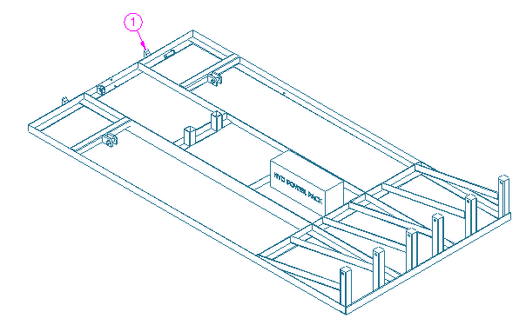

BOTTOM FRAME UNIT
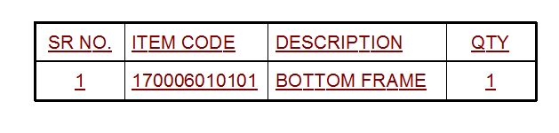

MANUAL
DOCK LEVELER
Manual Stopper Unit

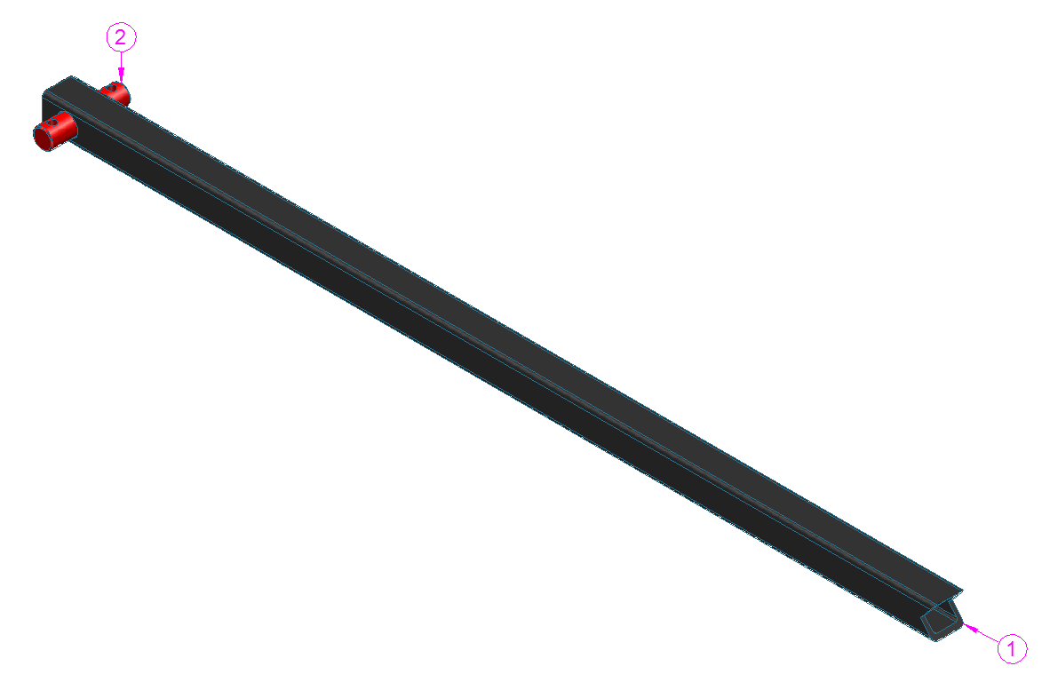

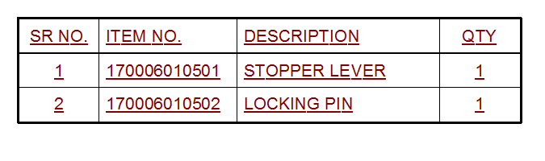

DOCK LEVELER
MANUAL

LIP UNIT

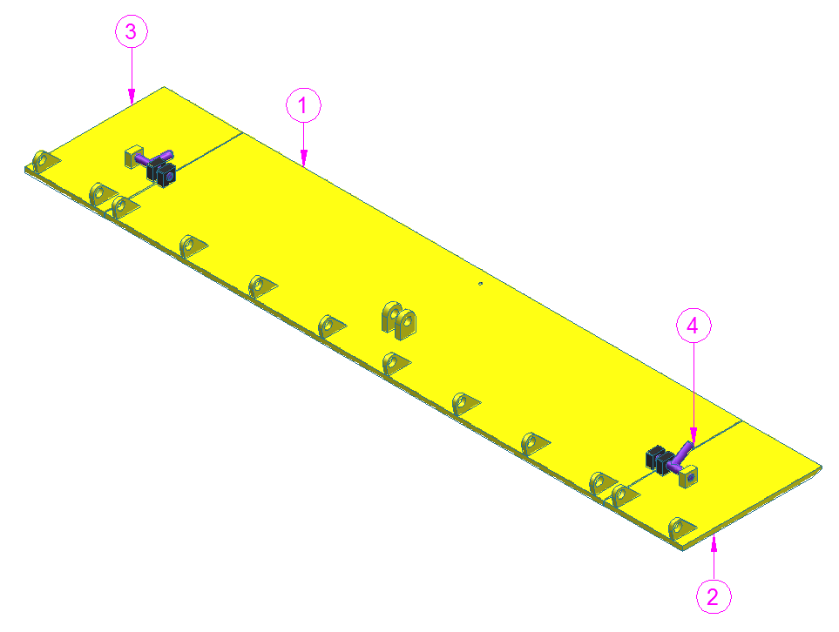
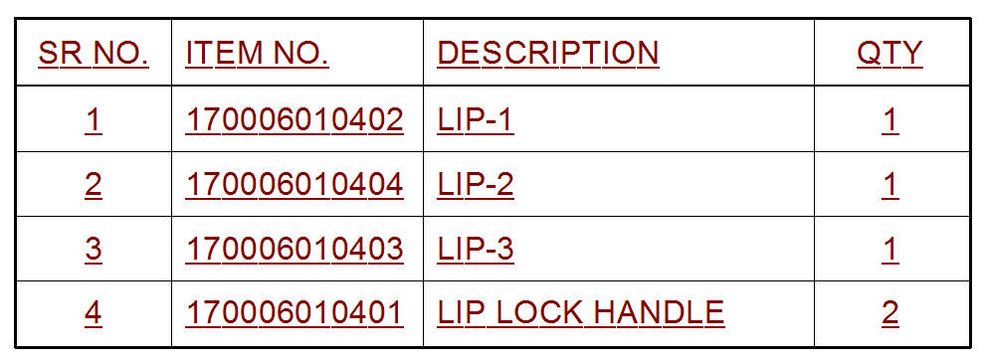
Top Frame Unit
DOCK LEVELER
MANUAL

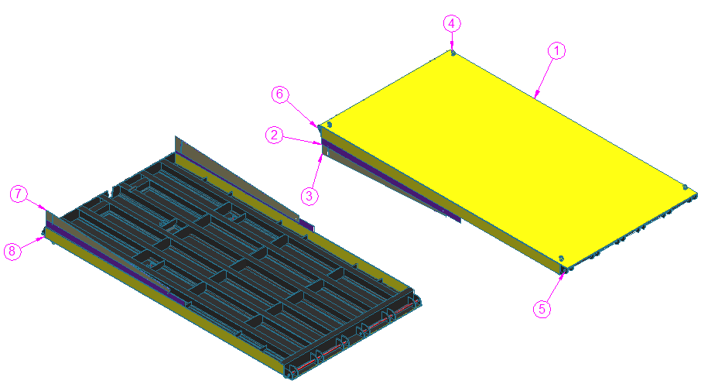

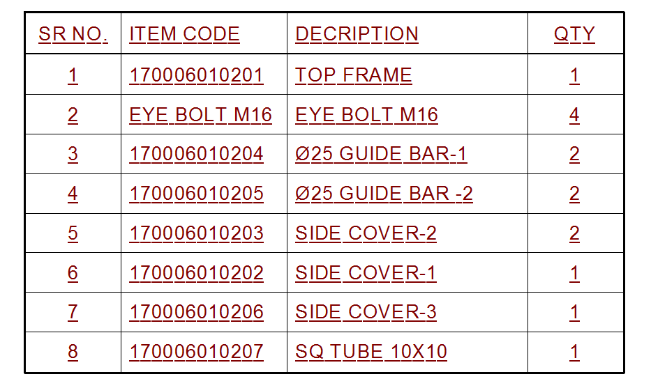
DOCK LEVELER
MANUAL

Safety Precautions - Dos and Don’ts

Do's of the system
- Power is switched off before entering into the Machine area for setting or maintenance.
- Press any E-Stop button (A red push button) and then follow the internal procedures of your company or organization for an emergency situation. Do not disconnect the power or Hydraulic supply to the system unless you are sure that nobody is trapped near the system. The E-Stop button is provided on Operator consol.
- Always ensure that system is” Switched off” while entering cell for maintenance or other activities.
- Use safety equipment’s like hand gloves etc.
- Use proper tools for the setting & maintenance activities.
- Clean the oil, dust & unwanted raw materials in the machine area after maintenance.

Don’ts of the system
- Do not set the system movements / programming with high speed.
- Do not bypass the limit switches of machines.
- Do not change the positions of the limit switches & dogs.
- Do not remove any covers.
- Do not lose the clamping screws on couplings, etc.
- Do not enter the machine when Auto cycle is ON.
- Do not alter the settings in the system.
- Do not put your hand while movement of torch slides while it is operating in given direction.
- Do not go away from the machine when machine is running.
– Note –
- Always maintain necessary logbooks for proper maintenance and Troubleshooting for trouble free production.
DOCK LEVELER
MANUAL

Preventive Maintenance
The importance of preventive maintenance cannot be over emphasized. Preventive maintenance will enable the machine to give long and trouble-free service.

Hydraulic Circuit of the machine
Sr. No. | Activity | Action | Daily | Weekly | Monthly | Half Yearly | Yearly
 | Oil | Check
 | Oil Leakage | Check and Take Corrective Action
 | Hydraulic Pressure Switch | Check / Replace
 | Oil Filter | Clean / Replace Cartridge *

DOCK LEVELER
MANUAL
SR. NO. | Activity | Action | Daily | Weekly | Monthly | Half Yearly | Yearly
1 | Tightening of Nuts on Piston Rod | Check / Tighten
2 | Sensors Sensitivity and Mounting | Check / Replace / Correct
3 | a) Foundation Bolts / Leveling Bolts | Check / Tighten
3 | b) All Hardware Tightening | Check / Tighten
4 | All parts in contact with the component (e.g. Resting blocks, Locating pins and Clamping pads.) | Check and replace

Hardware
DOCK LEVELER
MANUAL

Lubrication
Sr. No. | Activity | Action | Daily | Weekly | Monthly | Half Yearly | Yearly
 | Oiling of all moving joints | Check

Preventive Maintenance for Lubrication

Hydraulic System Components
DOCK LEVELER
MANUAL
Subsystem | Observation | Cause | Solution
Hydraulic fittings. | Oil leakage. | Joints or cracked tubes.  Loose fitting. | Check and replace tubes or other Hydraulic fittings.  Proper fitting of all connectors.
Hydraulic  cylinder. | Stroke of  The cylinder insufficient. | Oil pressure low. | Adjust pressure setting.
Hydraulic  cylinder. | Stroke of  The cylinder insufficient. | Oil leakage. | Check the Hydraulic circuit and Hydraulic fittings.
Hydraulic  cylinder. | Stroke of  The cylinder insufficient. | Mounting arrangement not proper. | Do the correct mounting arrangement.
Solenoid operated valve | Cylinder not actuating. | Solenoid coil failure. | Replace the valve. Check the valve operation using manual override button on the valve.
Solenoid operated valve | Cylinder not actuating. | Electrical supply to valve is not correct. | Check the electrical supply.
Solenoid operated valve | Cylinder not actuating. | Hydraulic supply failure  Solenoid failure due to sticky spool movement. | Check the hydraulic supply. Sometimes cleaning the valve assembly does help. However, this is a delicate and skilled job.
Flow Control Valve | Cylinder speed cannot be controlled satisfactorily | Flow control valve setting wrong. | Set the FCV correctly. Note that most of the Flow Control implementations are generally “Meter Out”. In case of clamping application, the flow control implementations are “Meter In”.
Flow Control Valve | Cylinder speed cannot be controlled satisfactorily | Dust, dirt in the valve in the Hydraulic circuit. | Clean the FCV regularly.
Flow Control Valve | Oil leakage from FCV | Breakage of FCV | If defective then replace it.
Hydraulic faults & Troubleshooting. If a fault cannot be cured or if there is a serious mechanical or electrical failure, you should contact
NIHVA TECHNOLOGIES Pvt. Ltd.
G-BLOCK, 1ST FLOOR, THERMAX CHOWK
MIDC, ABOVE RENAULT SHOWROOM
CHINCHWAD, PUNE-411019

TEL.NO. - +912066304033
EMAIL: -info@nihva.com
www.nihva.com

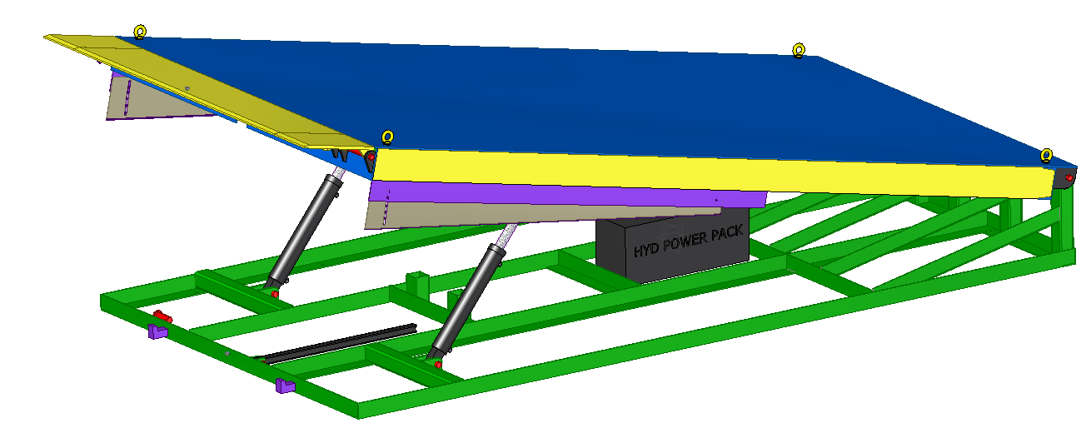
DOCK LEVELER
MANUAL

